OnPrem SQL Data migration to Azure ADLS Using Microsoft Azure Data Factory

Step-1:
Create a Project Folder Under Pipeline and then give the pipeline name shown as below along with the configurations:
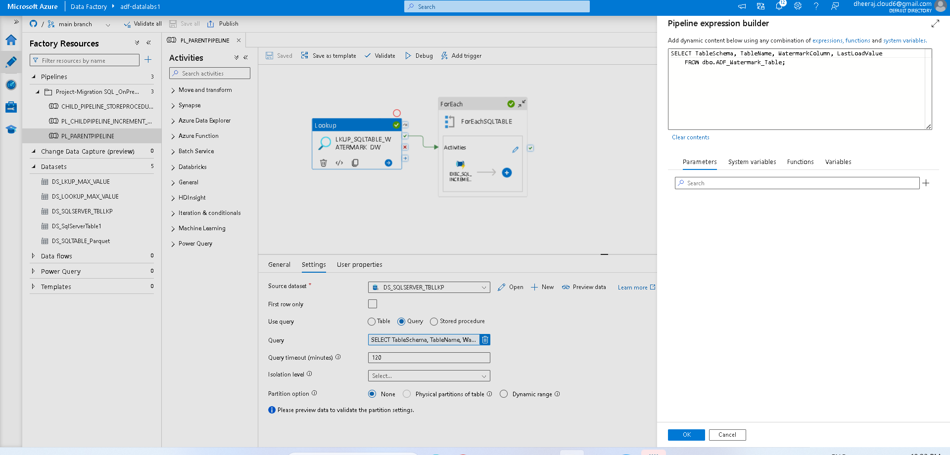

Step-2:
Now click on Source DataSet “DS_SQLSERVER_TBLLKP” and update the parameters on Linked Service “LS_SQLSERVER_TBLLKP” also choose the Table details such as “dbo.ADF_Watermark_Table”.

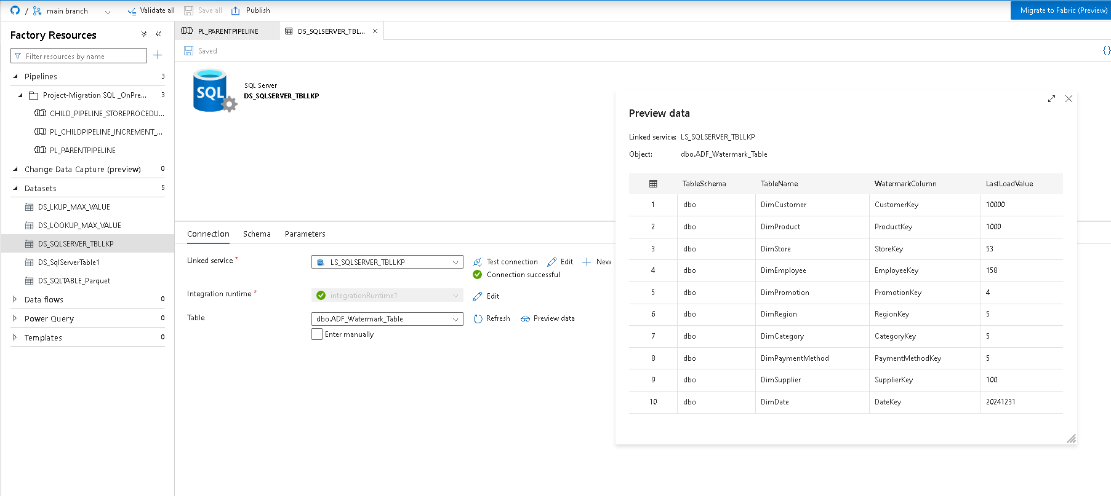
Step-3:
On Parent Pipeline choose the Lookup Activity as shown as below and update the required data.
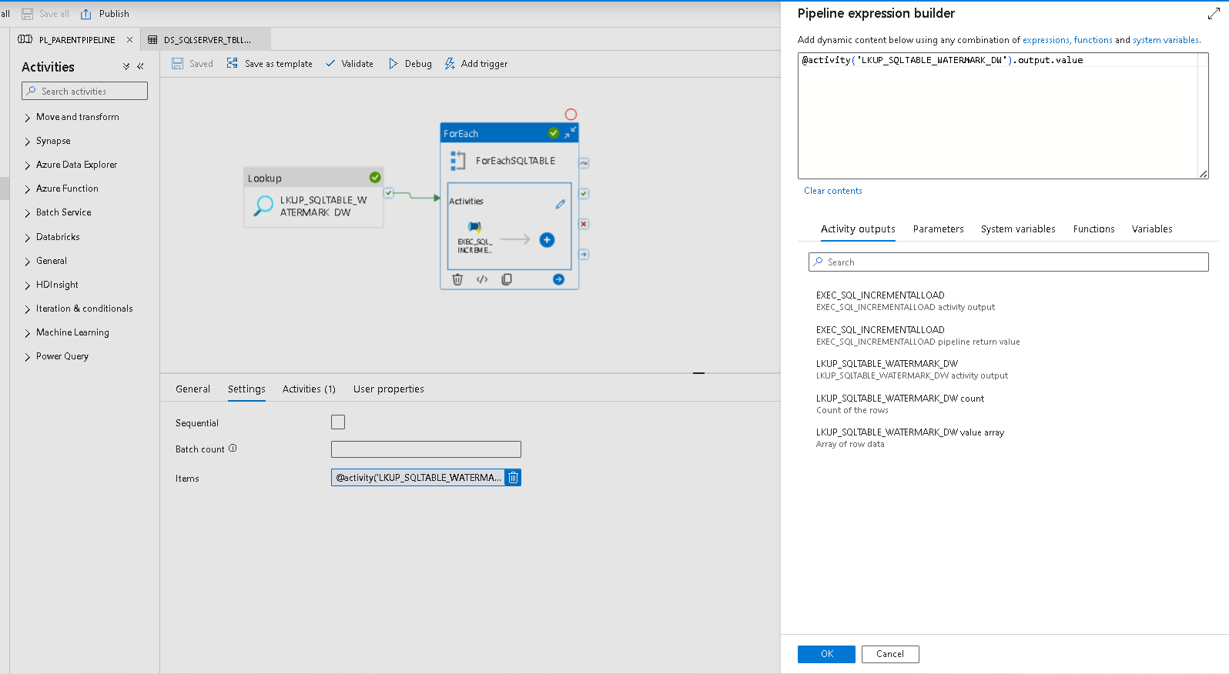

Step-4:
Update the activity such as execute when the new data is added on the tables, and also configure the invoked pipeline details “PL_CHILDPIPELINE_INCREMENT_LOAD” to execute further steps.
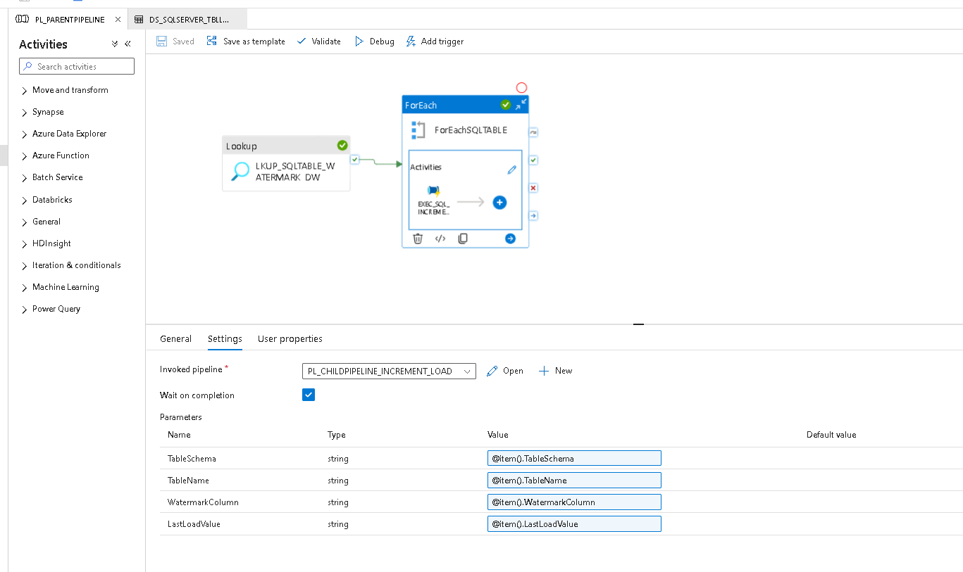

Step-5:
Now goto Child pipeline and configure the Lookup activity and Ifcondition steps. Also update the parameters details such as below.
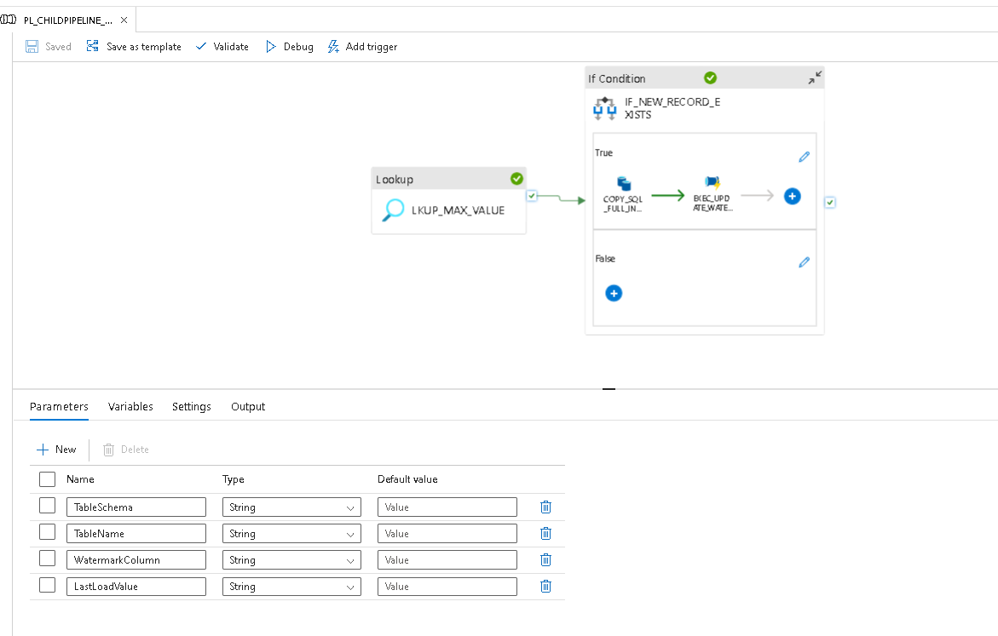
Then try to run the debug option for the child pipeline and check whether the configuration is placed as expected or not as you can see the Output details below.

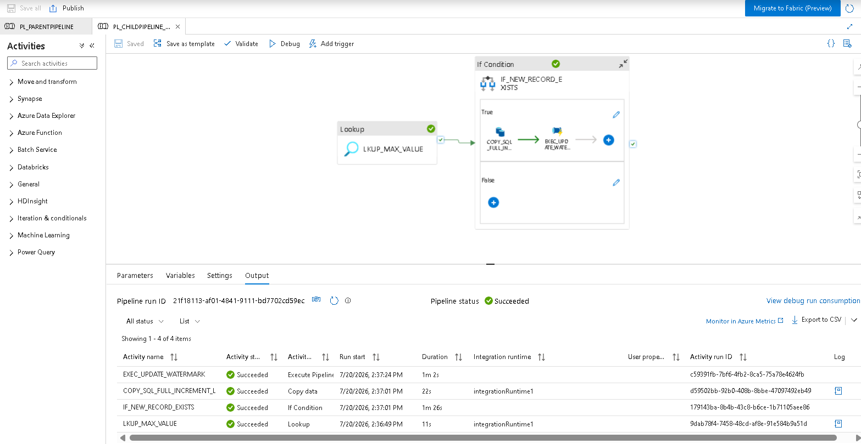

Step-6:
Now goto Lookup activity and update the configuration such as below with Dataset and LinkedService such as below.
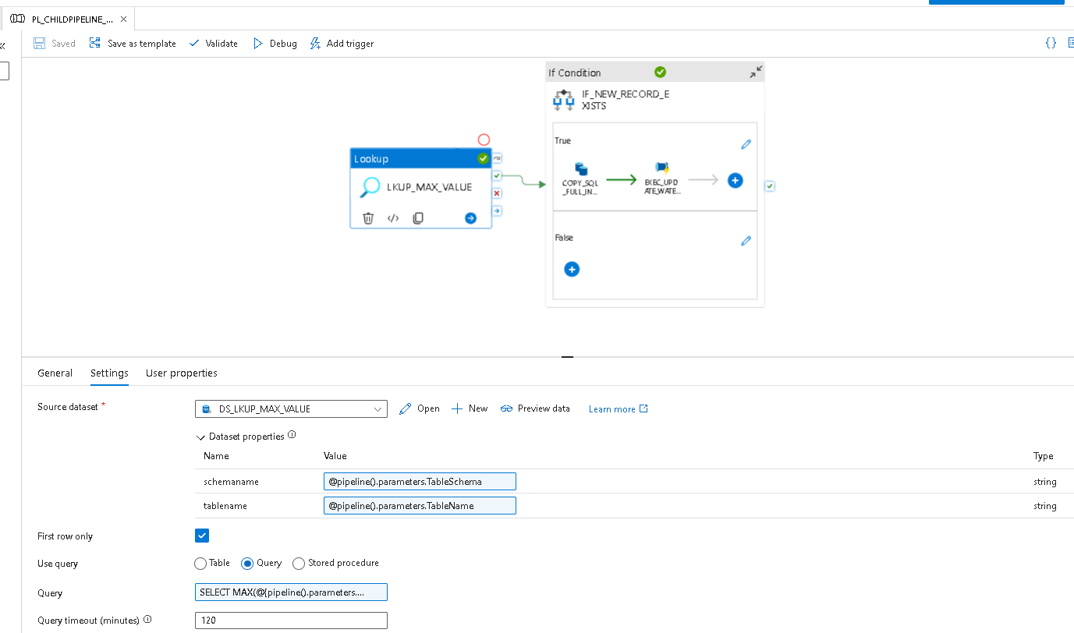

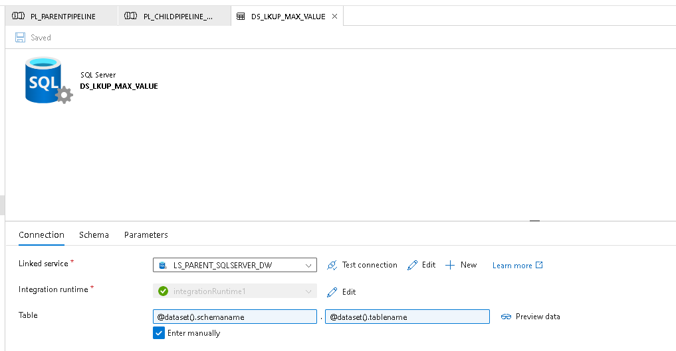

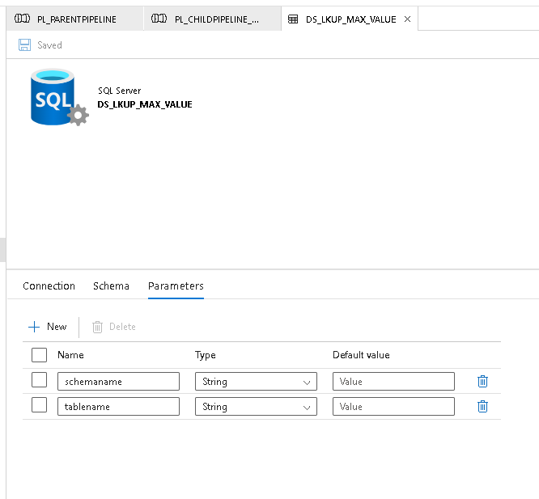
Step-7:
Now configure the IF Condition with below details.
@or(equals(pipeline().parameters.LastLoadValue, null), greater(int(activity('LKUP_MAX_VALUE').output.firstRow.MaxValue), int(pipeline().parameters.LastLoadValue)))

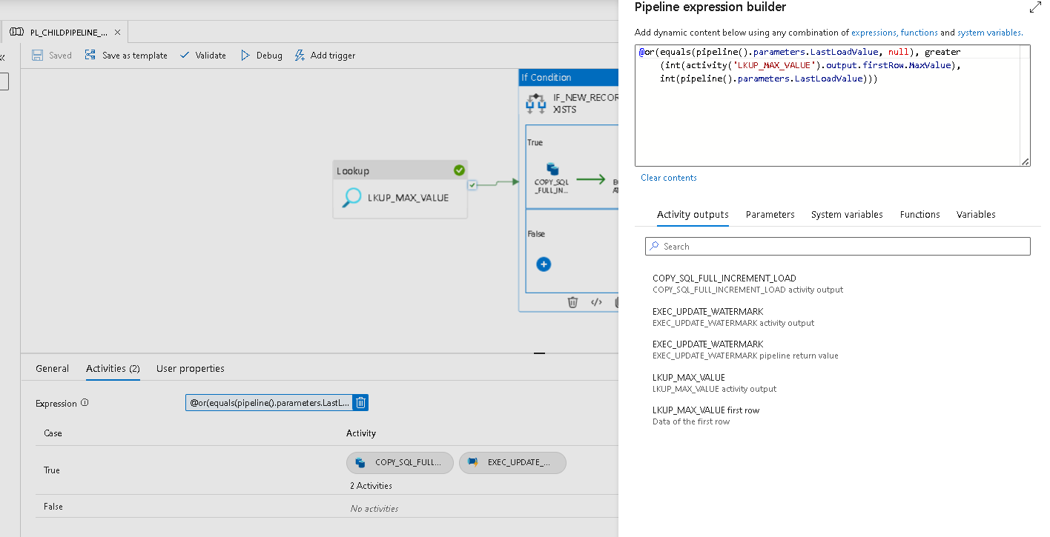

Now configure the TRUE Condition details such as below.
Name: COPY_SQL_FULL_INCREMENT_LOAD
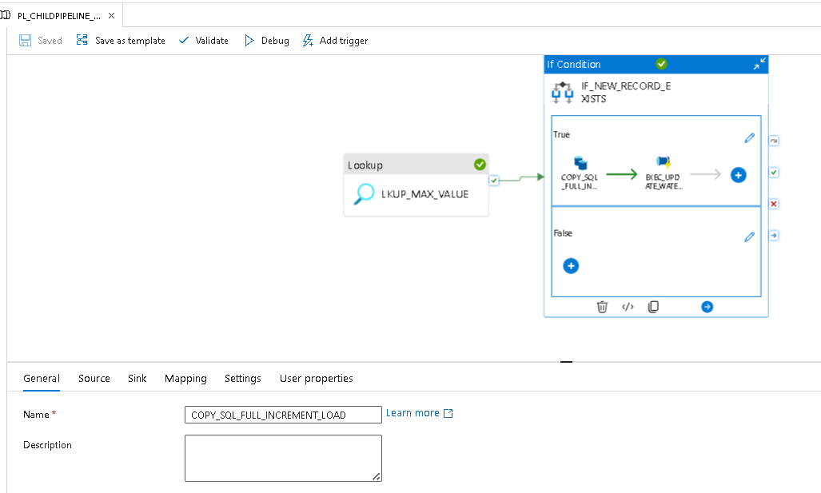
Now goto source tab and update the Dataset Properties and Query fields such as below.
@concat(
'SELECT * FROM ',
pipeline().parameters.TableSchema, '.', pipeline().parameters.TableName,
if(
equals(pipeline().parameters.LastLoadValue, null),
'',
concat(
' WHERE ', pipeline().parameters.WatermarkColumn,
' > ''', pipeline().parameters.LastLoadValue, ''''
)
)
)

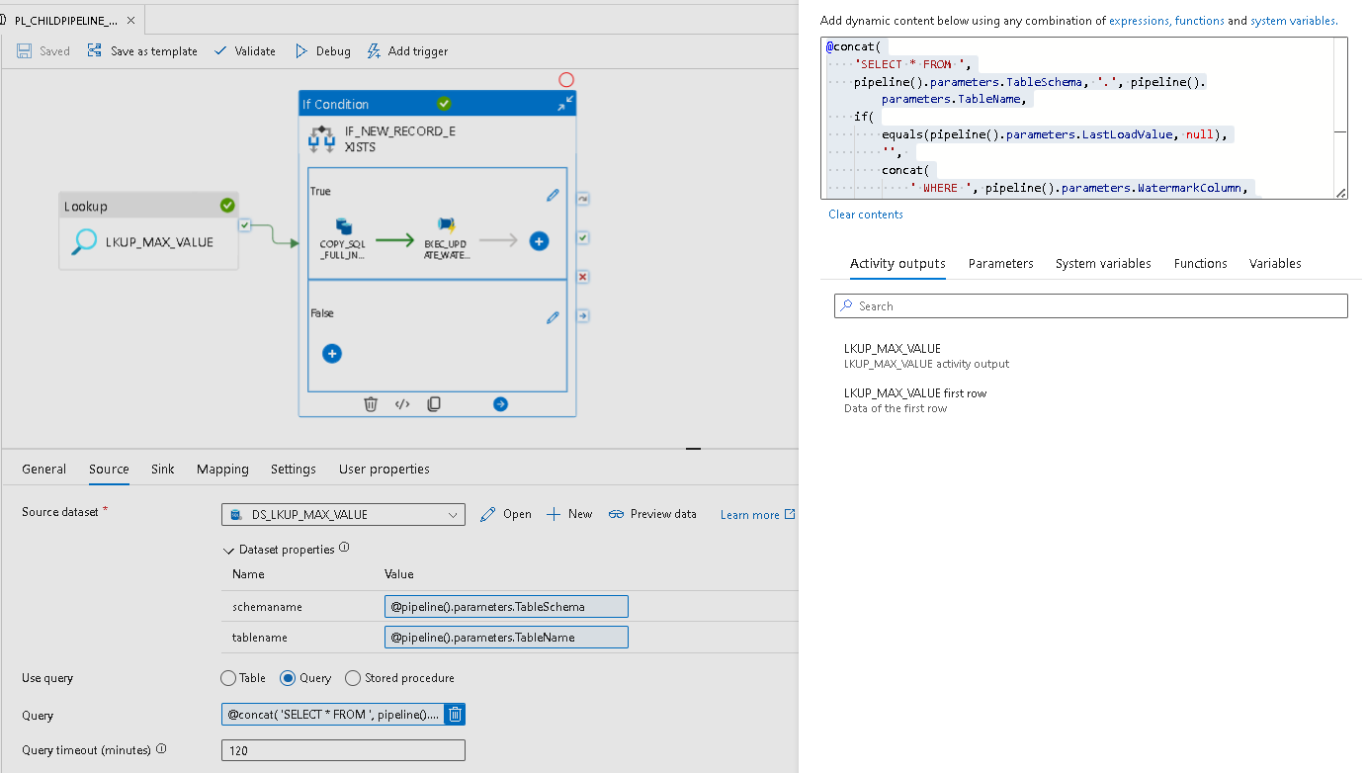Also update the sink details on the child pipeline.
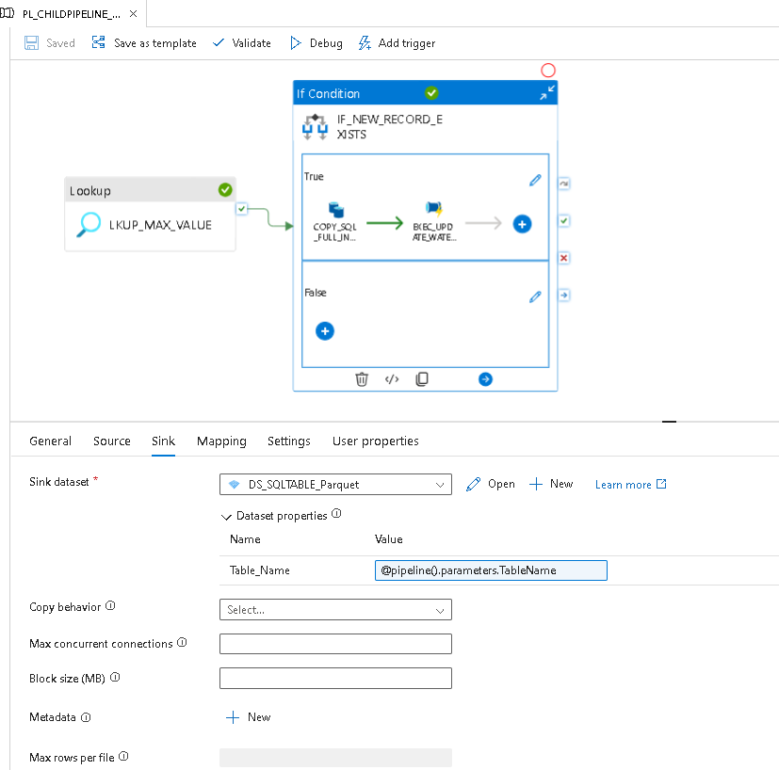
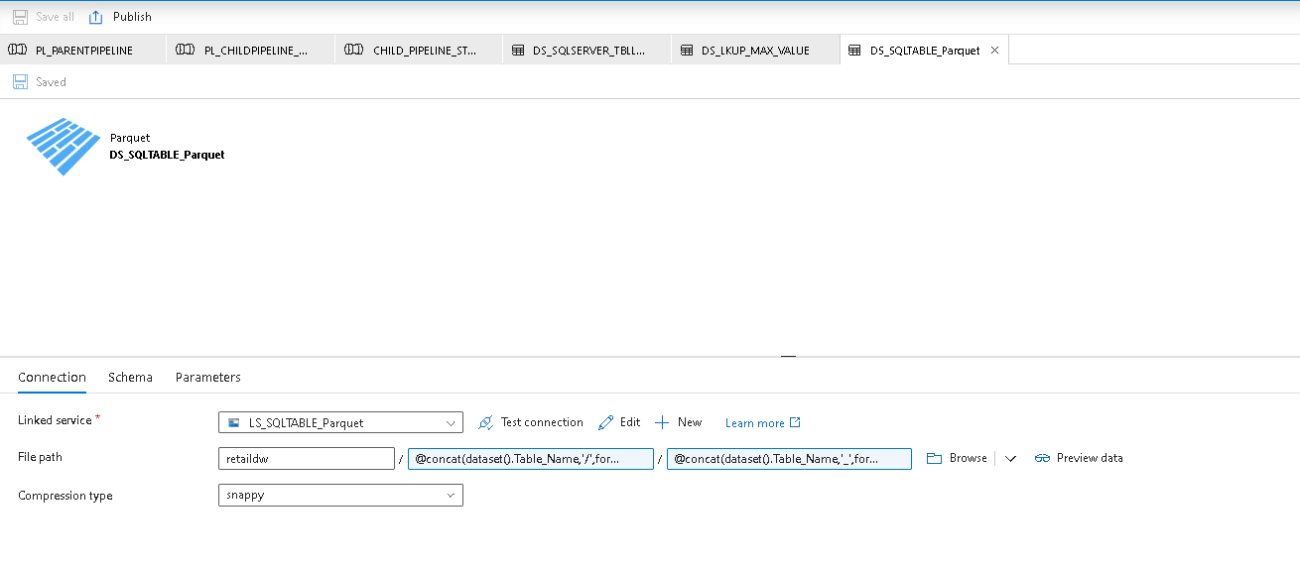
Update the Linked Service “LS_SQLTABLE_Parquet” and FilePath of the ADLS Storage account such as below to upload the data based on the folders such as year, month and date folderpath.
Add the expression such as Foldername / @concat(dataset().Table_Name,'/',formatDateTime(utcNow(),'yyyy/MM/dd'))
/ @concat(dataset().Table_Name,'_',formatDateTime(utcNow(),'yyyyMMddHHmmss'),'.parquet')

Step-8:
Now include the execute pipeline activity “EXEC_UPDATE_WATERMARK” and goto setting tab and update the below details. Here the configure is set with Invoked Pipeline “CHILD_PIPELINE_STOREPROCEDURE” which needs to execute post completion of the Copy activity.
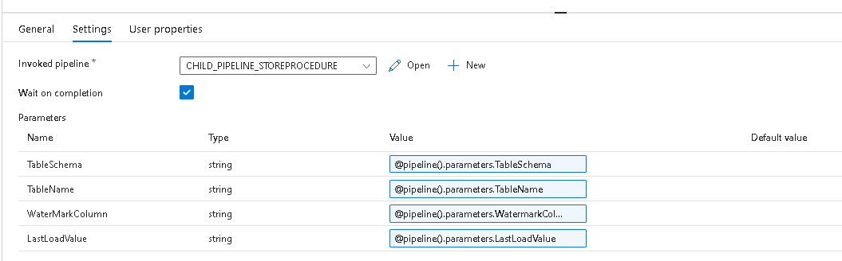

Step-9:
Now goto the Invoked pipeline “CHILD_PIPELINE_STOREPROCEDURE” and update the parameters shown as below.
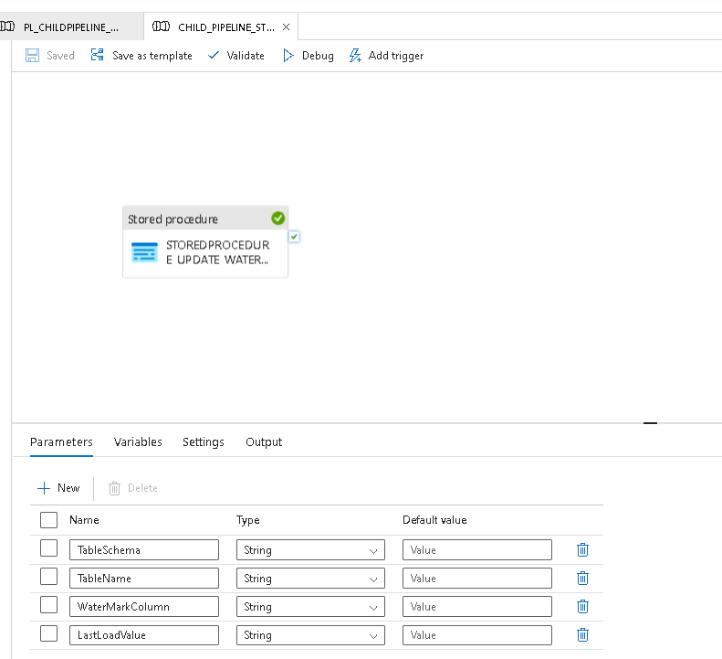
Click on the Stored procedure and update the name “STOREDPROCEDURE_UPDATE_WATERMARK” shown as below.
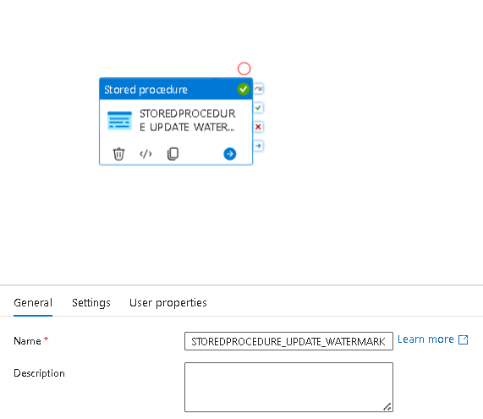

Now goto settings tab and update the Linked Service “LS_ONPREM_SQLSERVER_DW” and stored procedure name “[dbo].[UpdateWaterMark]” and its parameters shown as below.
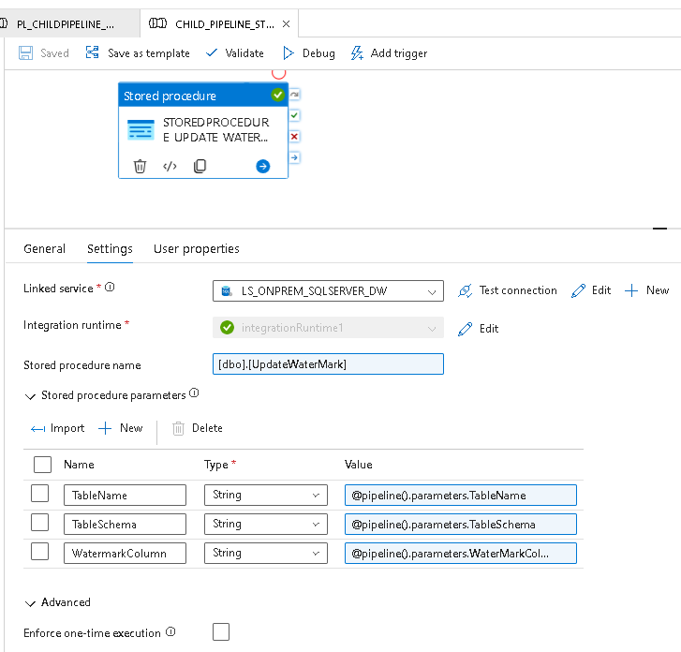
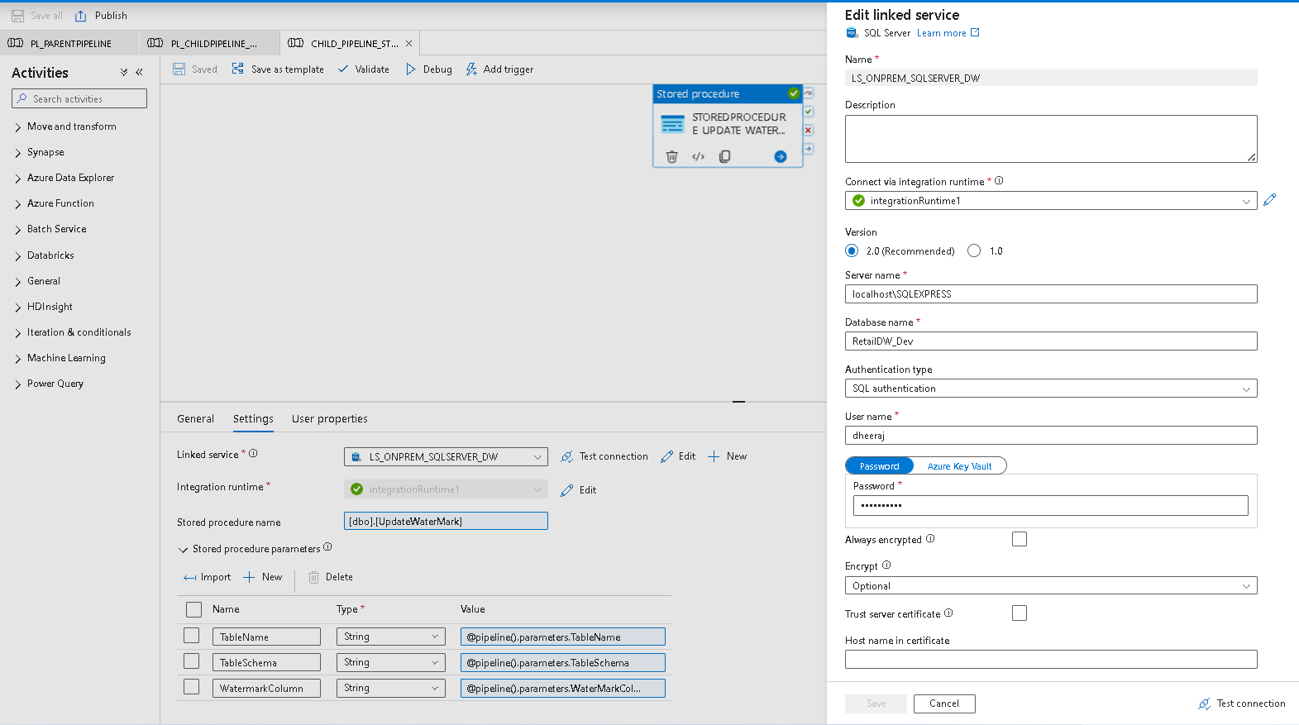
Step-10:
Once everything is configured then try to run the masterpipeline and debug it. Also save the data and validate and then Publish the pipeline then the executed data will get updated into the Github repository which is configured in our Data factory configuration.
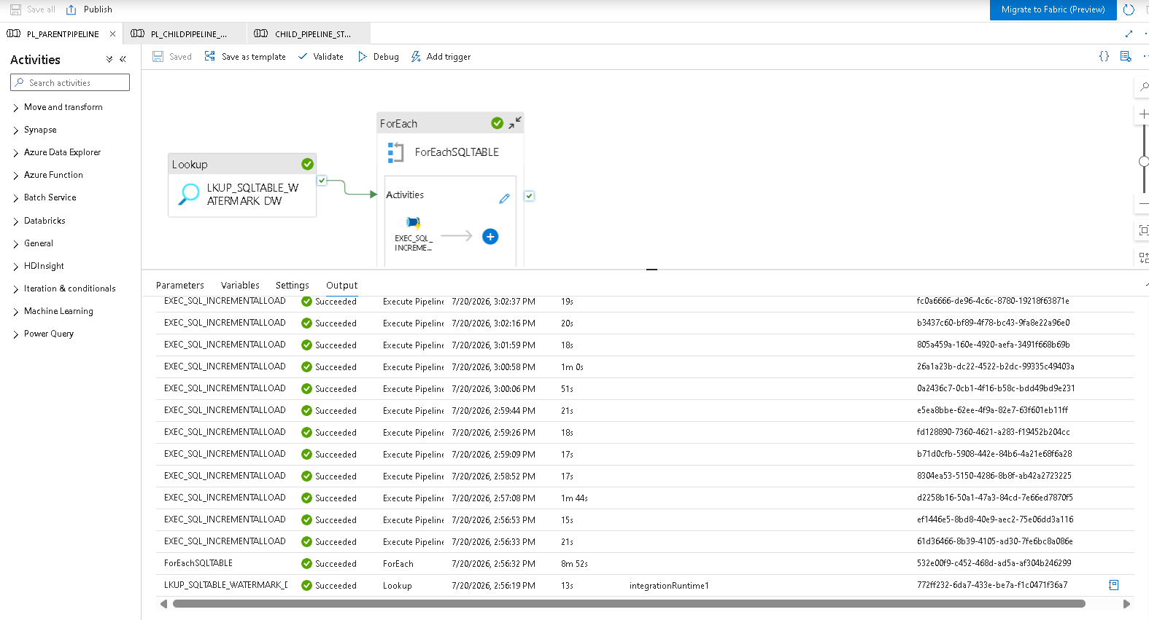

GitHub Configuration with ADF:
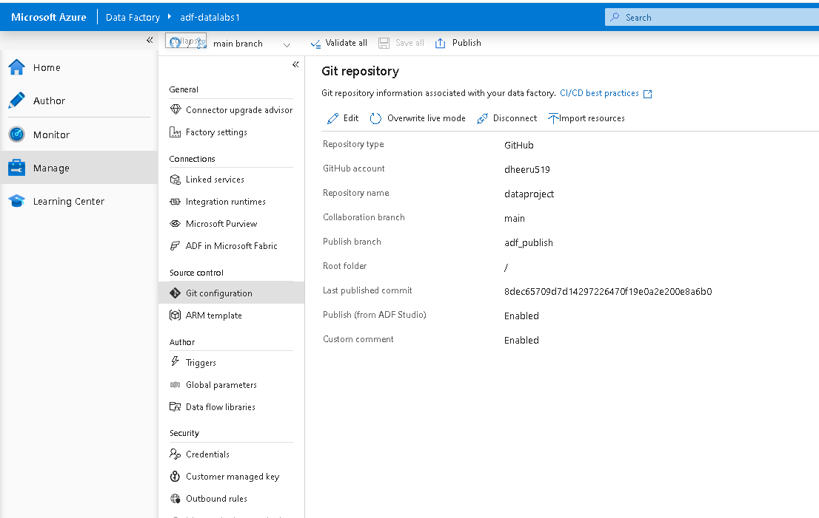
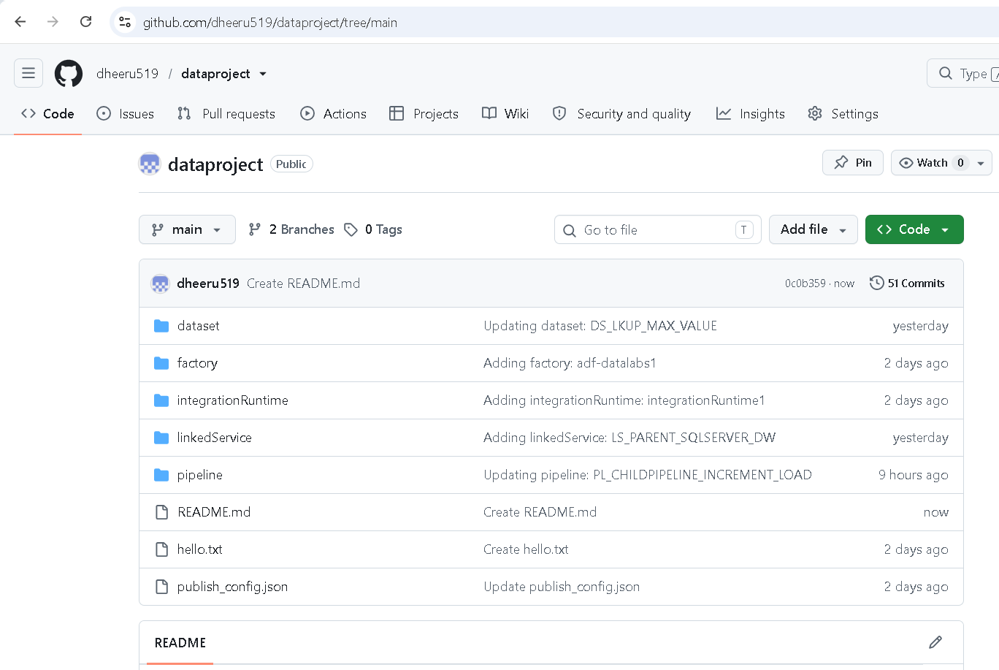
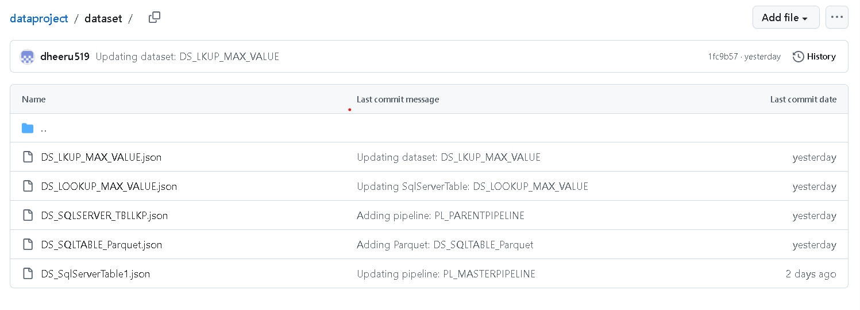
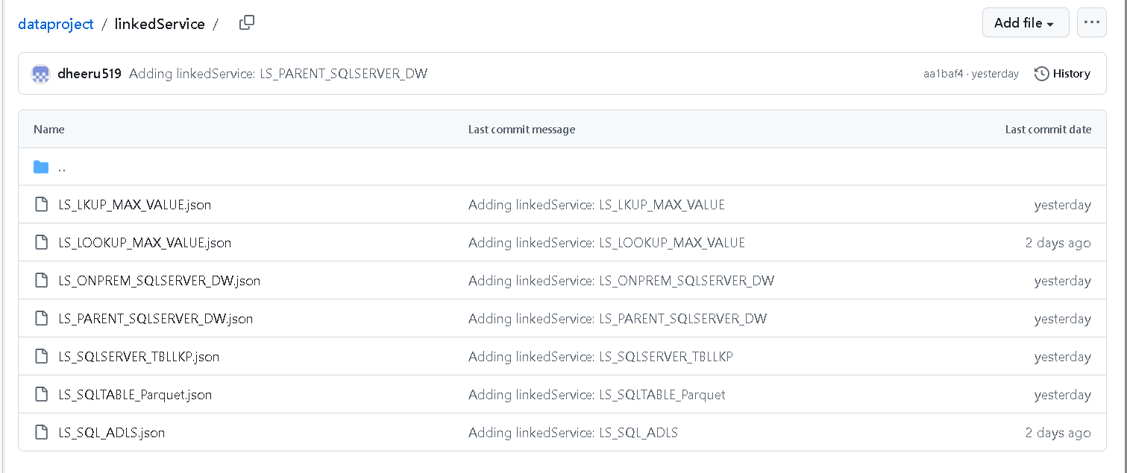
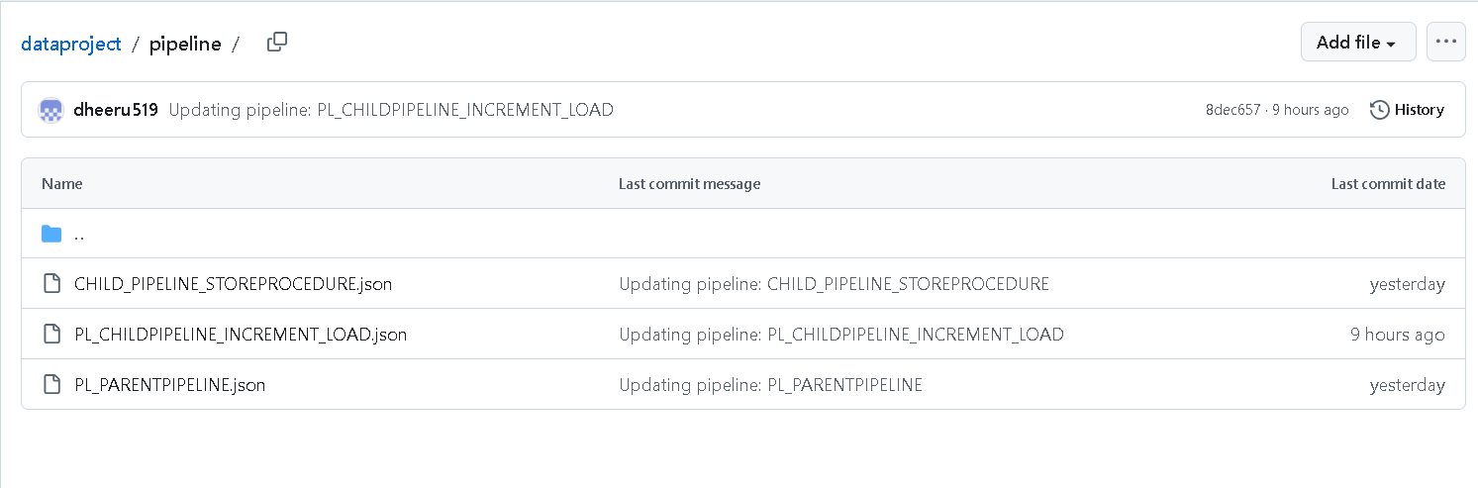
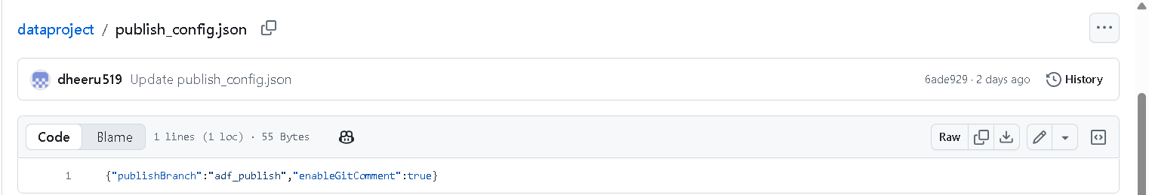

Also I have tested the pipeline after adding few rows and colums on the table and then executed the query to update the table with latest data and its fetched into the ADLS container.
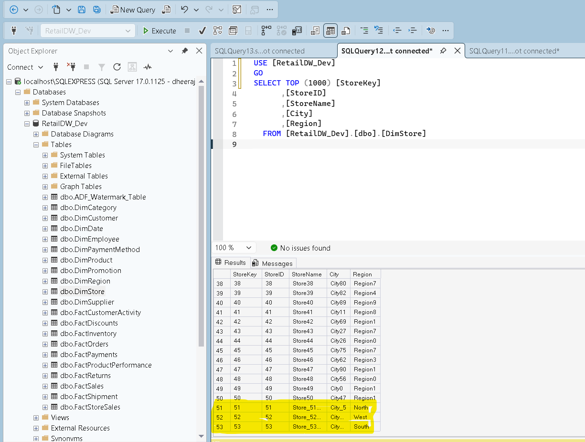

Here is the updated parquet data after updating the above tables data into the Database. It got updated to Azure ADLS storage account container with the mentioned folderpath.
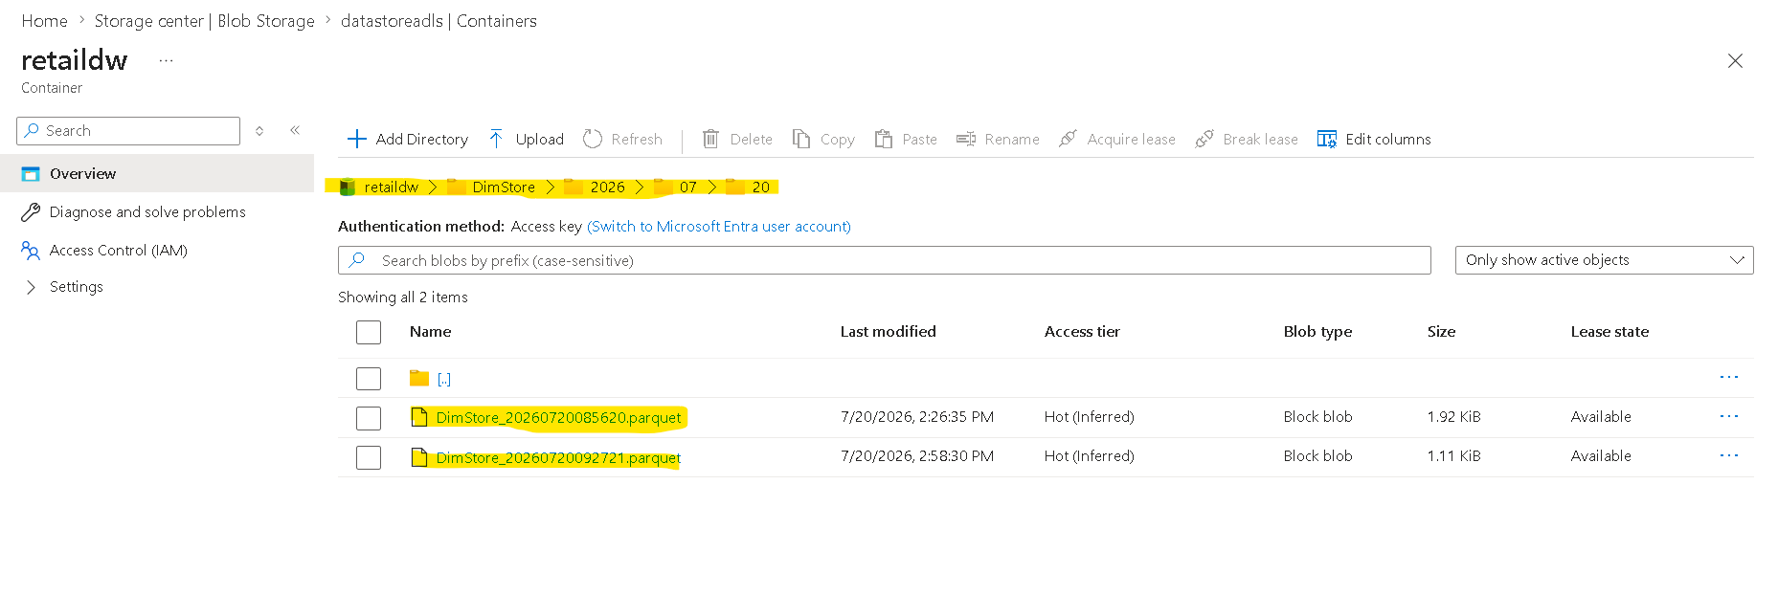

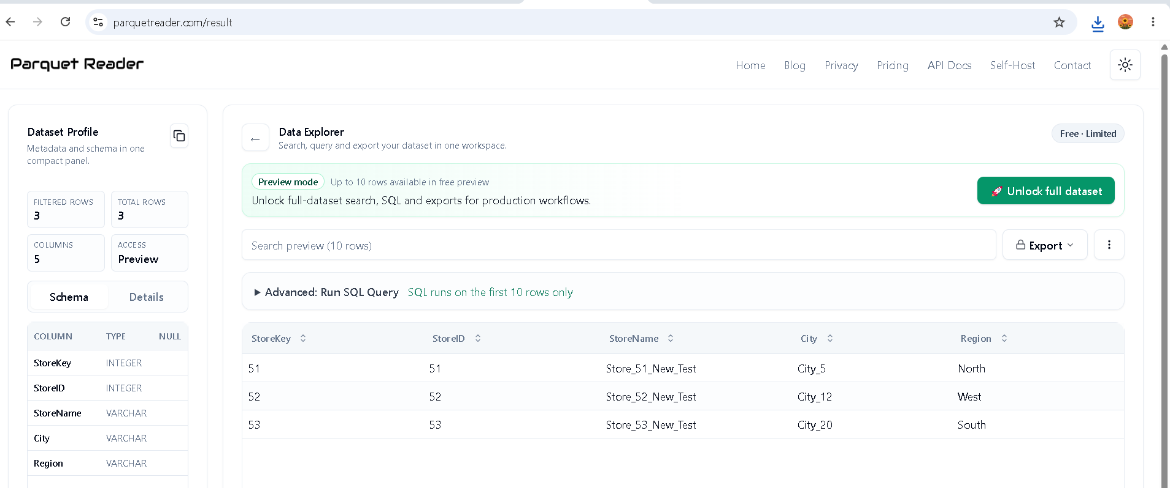

=============================END=================================

